Department | FED
Subject | DSA-2
Academic Year | I-III SEMESTER (2025-26)
Faculty Name | M D RAZIA
Student Name | VUNGARALA MOUKTHIKA
Roll Number | 2520030298
Branch | CSE
Course Outcome | CO-5

Case study Topic: Cricket Scoring Service – Sorting 1 Million Ball-by-Ball Records using Stable Counting Sort

Work Done Summary:
In this case study, stable counting sort was used to arrange cricket delivery records based on the composite key (over, ball). The sorting was performed using the LSD approach by first sorting the records according to ball number and then stably sorting them by over number. A Java implementation of stable counting sort was developed and its time complexity was analyzed. The performance of counting sort was also compared with other sorting algorithms, and an external merge sort solution was discussed for handling large datasets that exceed available memory.
Implementation Details:
- Store each cricket delivery record using a composite key (over, ball).
- Apply stable counting sort on the ball field (least significant key).
- Count the frequency of each ball number and compute prefix sums.
- Place records into an output array using reverse traversal to maintain stability.
- Apply stable counting sort again on the over field (most significant key).
- Count over frequencies, compute prefix sums, and place records into a new output array.
- The stability of the second sort preserves the ball ordering established in the first sort.
- The final output is a chronologically sorted list of deliveries based on (over, ball).
Result: Screenshots / Output
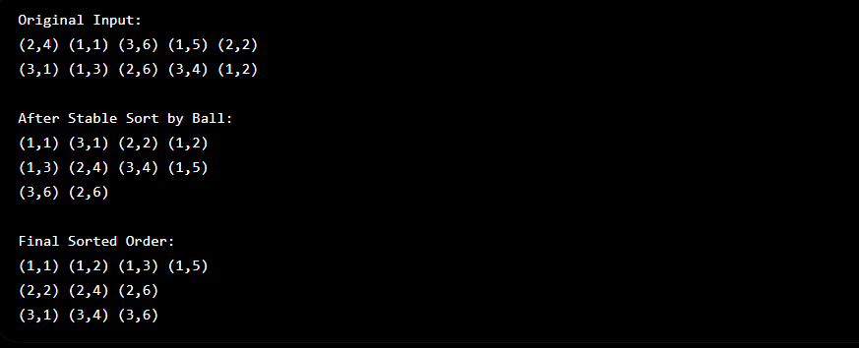

GitHub Link: moukthikavungarala/Case-Study-Project

Student Signature | Faculty Signature
__________________ | _________________

